1. Expand figure 2.48 from the textbook to take all Hexadecimal characters 0-F.

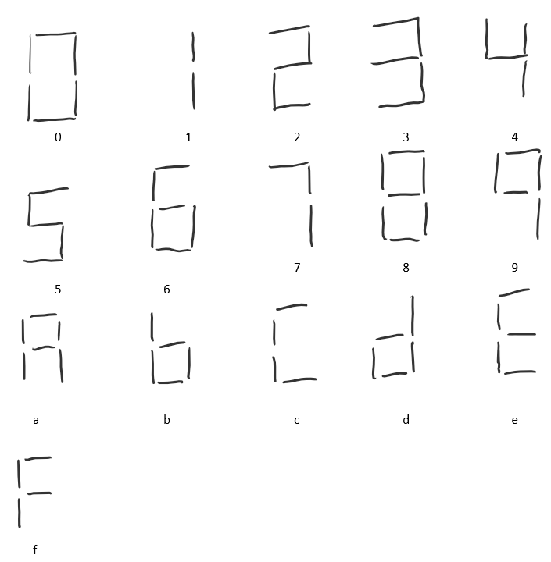

2. Remake Table 2.6 from the textbook to reflect the figure created in question 1 using active low hardware. This means draw the truth table for hexadecimal version

|  |  |  |  |  |  |  |  |
| --- | --- | --- | --- | --- | --- | --- | --- |
| D3:0 | Sa | Sb | Sc | Sd | Se | Sf | Sg |
| 0000 | 1 | 1 | 1 | 1 | 1 | 1 | 0 |
| 0001 | 0 | 1 | 1 | 0 | 0 | 0 | 0 |
| 0010 | 1 | 1 | 0 | 1 | 1 | 0 | 1 |
| 0011 | 1 | 1 | 1 | 1 | 0 | 0 | 1 |
| 0100 | 0 | 1 | 1 | 0 | 0 | 1 | 1 |
| 0101 | 1 | 0 | 1 | 1 | 0 | 1 | 1 |
| 0110 | 1 | 0 | 1 | 1 | 1 | 1 | 1 |
| 0111 | 1 | 1 | 1 | 0 | 0 | 0 | 0 |
| 1000 | 1 | 1 | 1 | 1 | 1 | 1 | 1 |
| 1001 | 1 | 1 | 1 | 0 | 0 | 1 | 1 |
| 1010 | 1 | 1 | 1 | 0 | 1 | 1 | 1 |
| 1011 | 0 | 0 | 1 | 1 | 1 | 1 | 1 |
| 1100 | 1 | 0 | 0 | 1 | 1 | 1 | 0 |
| 1101 | 0 | 1 | 1 | 1 | 1 | 0 | 1 |
| 1110 | 1 | 0 | 0 | 1 | 1 | 1 | 1 |
| 1111 | 1 | 0 | 0 | 0 | 1 | 1 | 1 |